Creating a Queue-🡪 queue name🡪q1webgui

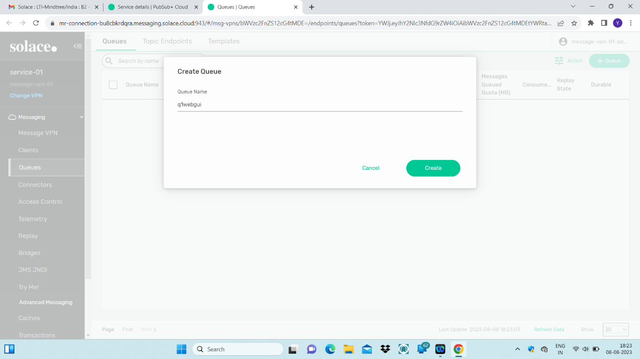

Changing Queue Properties🡪Message-Queued Quota and Maximum consumer count and owner can also be given as default.

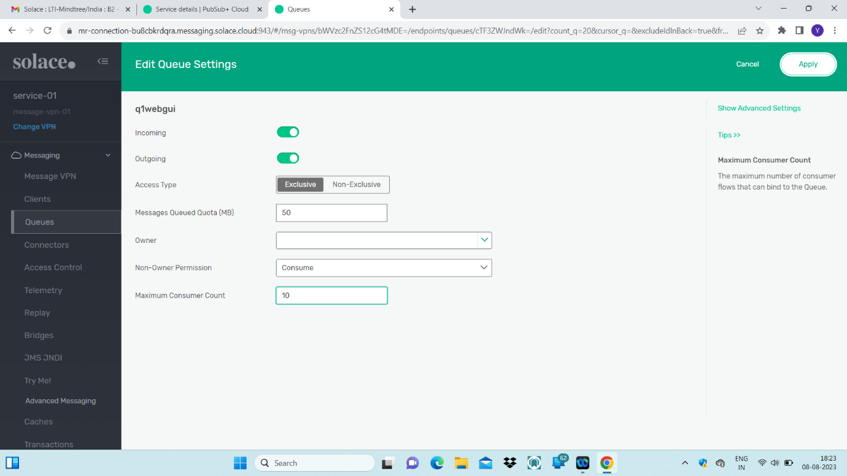

A subscription is added to the queue and the topic to which queue is subscribed is try-me1

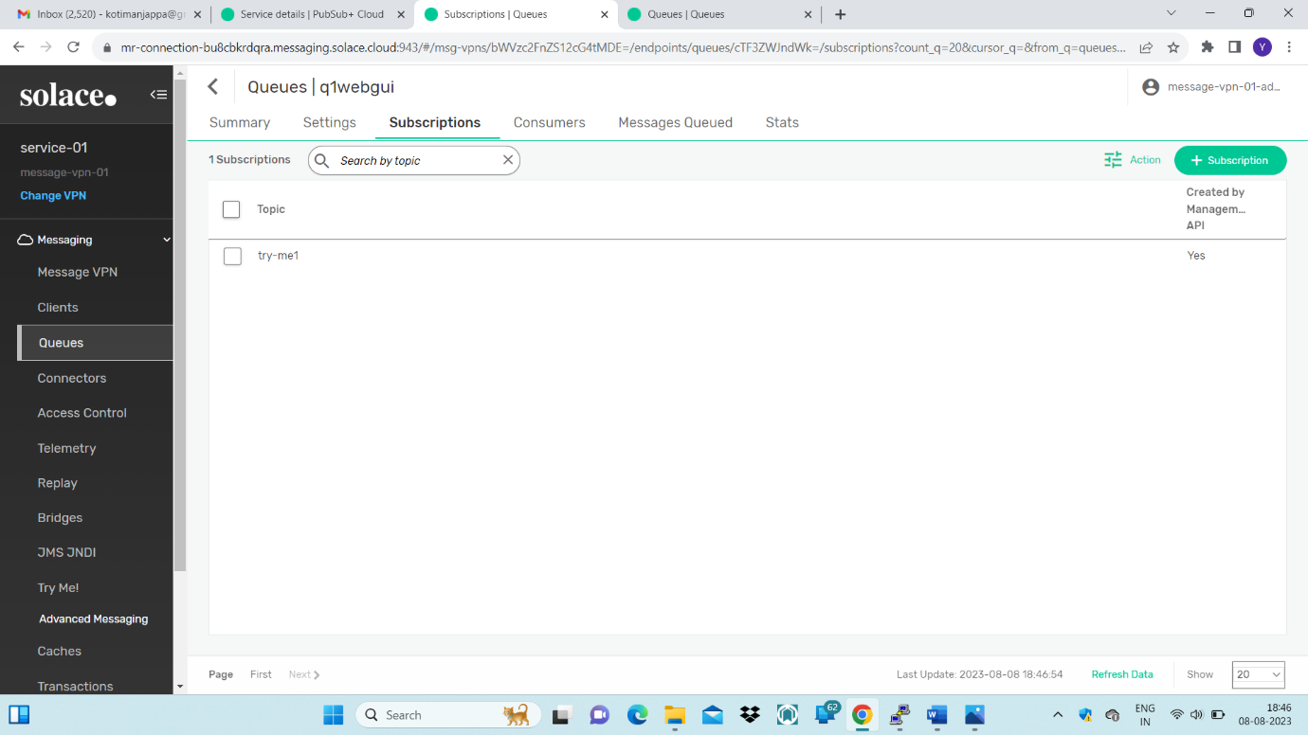

Message is published.

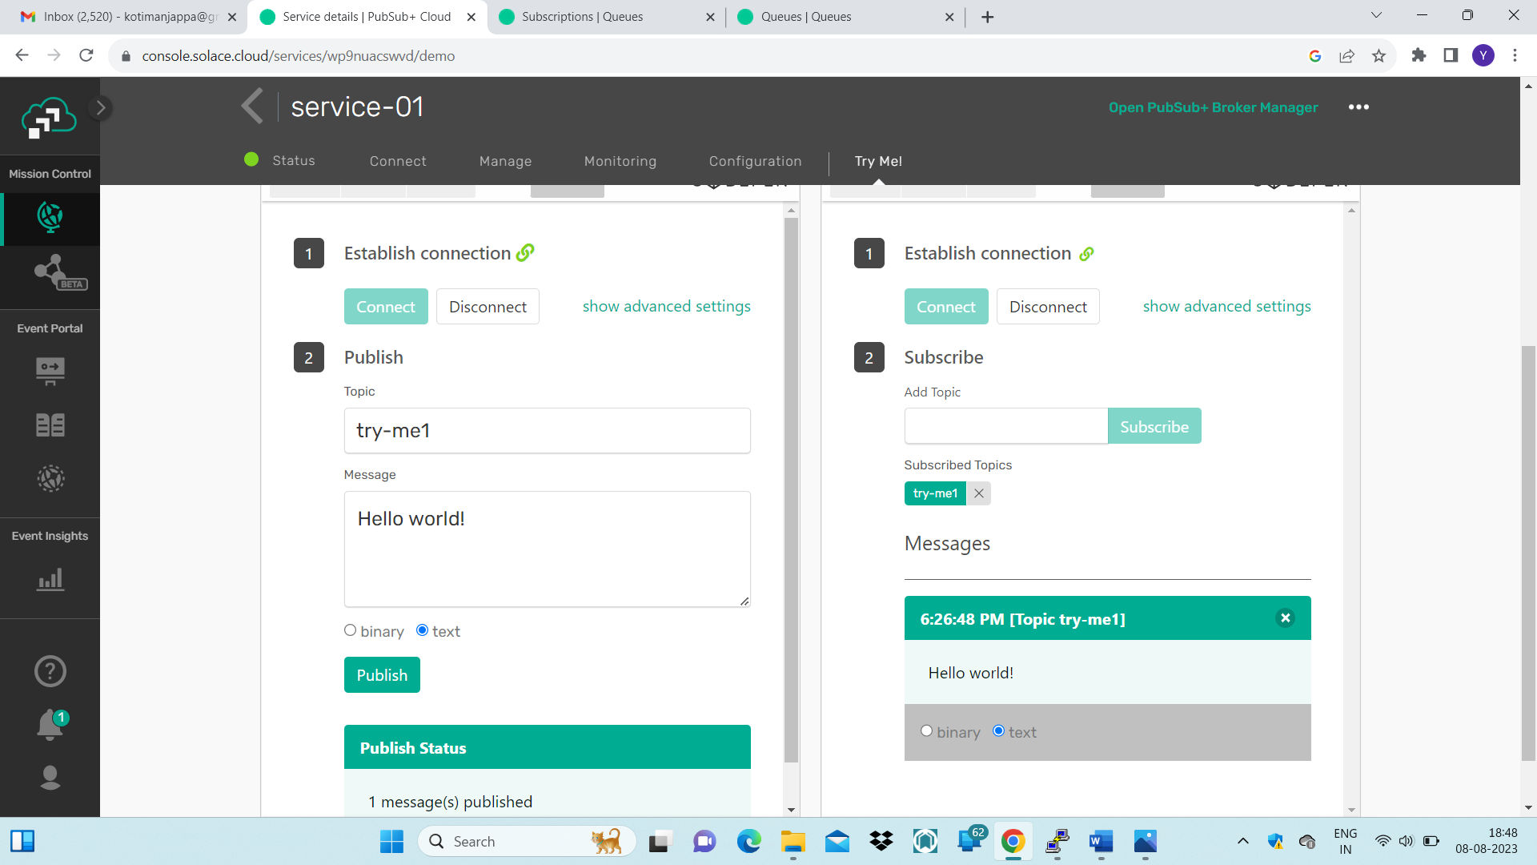

Message meta data can be seen here in message queued.

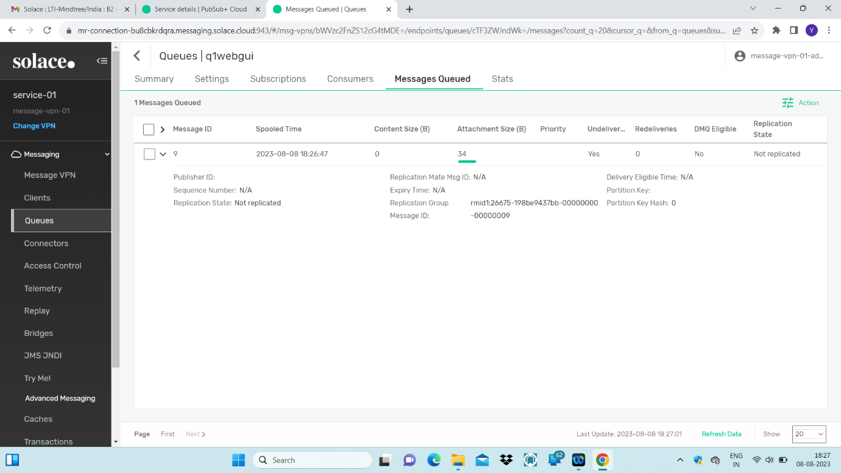

Creating q01cli and qcli02 using SOLACE CLI🡪

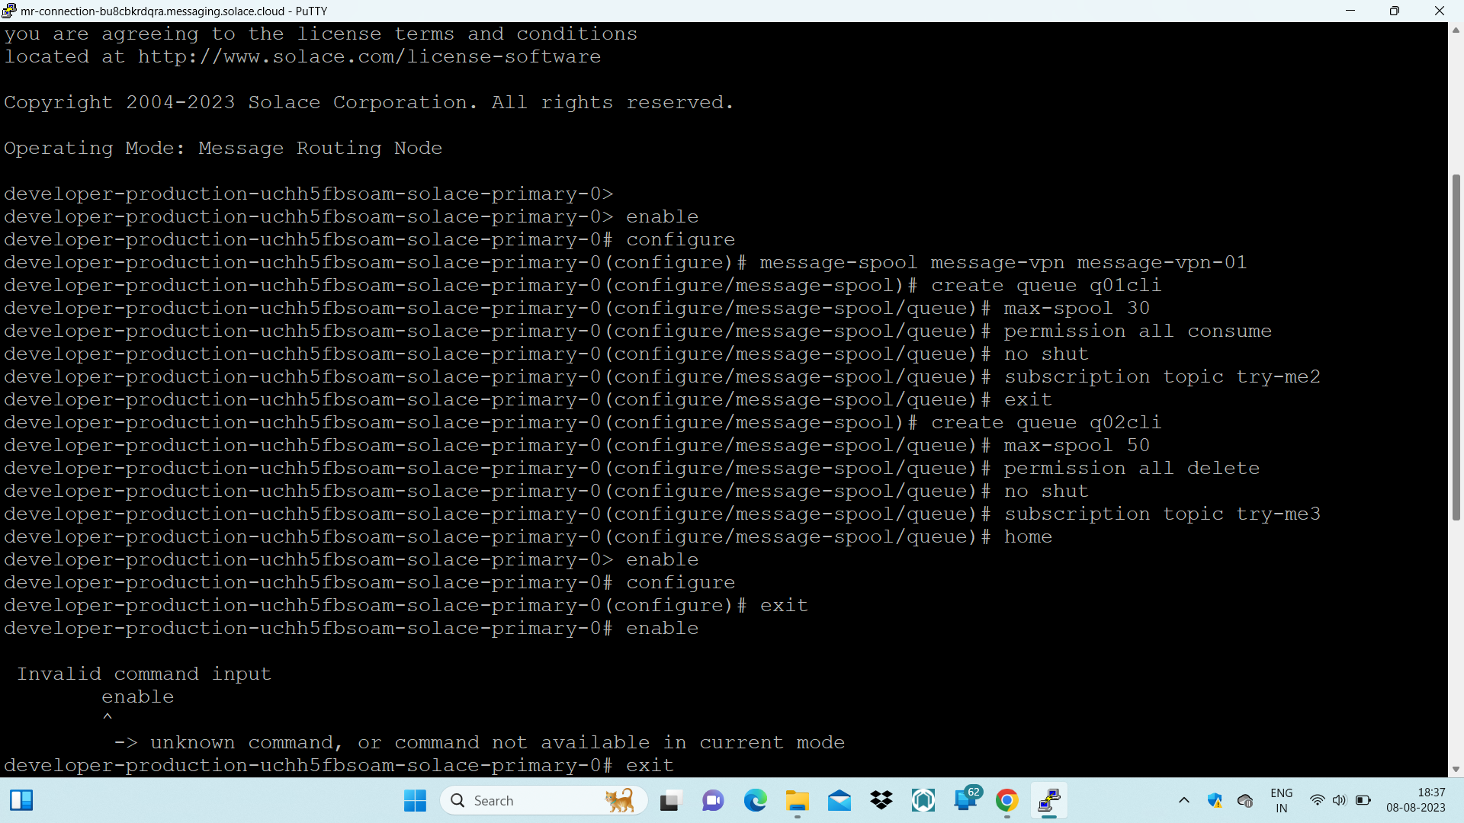

LISTING THE QUEUE-🡪Command: show queue \*

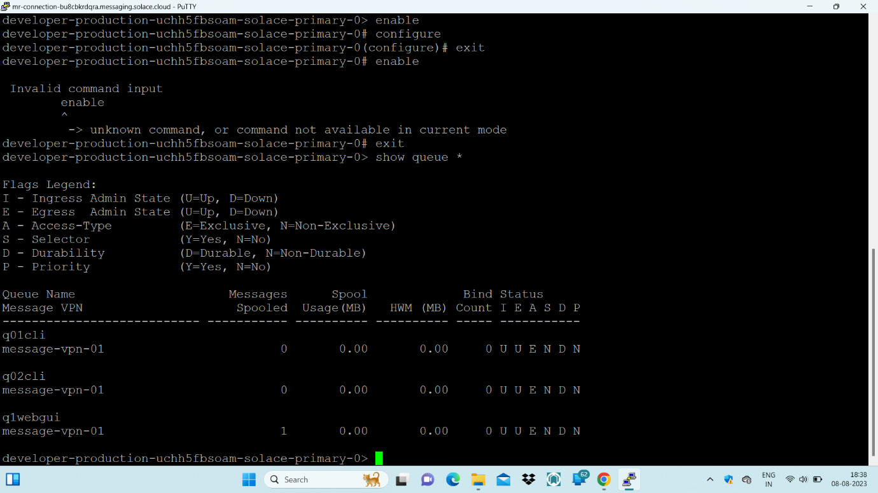

Displaying the detail about particular queue-🡪Command: show queue q01cli detail

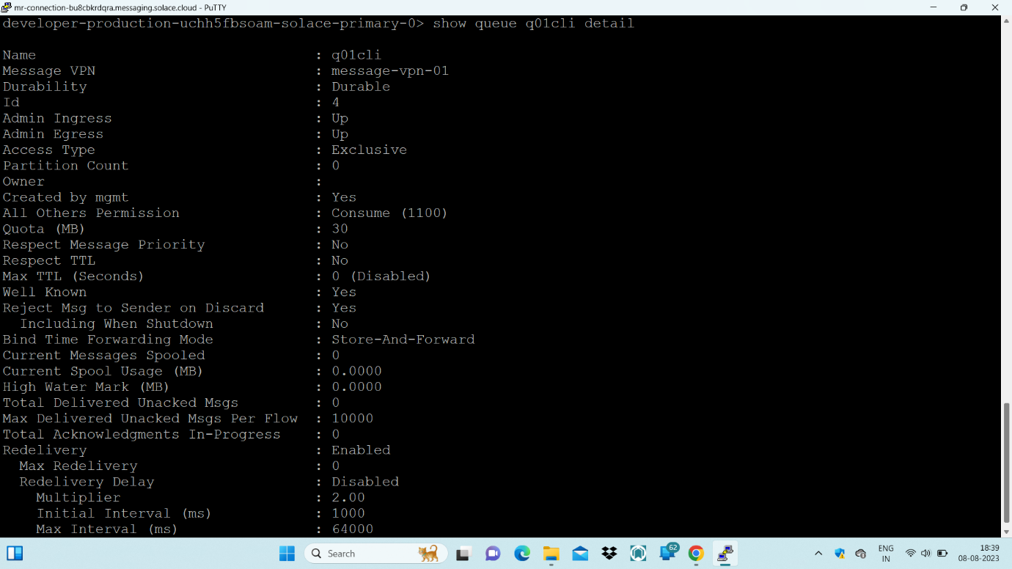

Displaying detail about message VPN🡪Command: show message-vpn <message-vpn name>

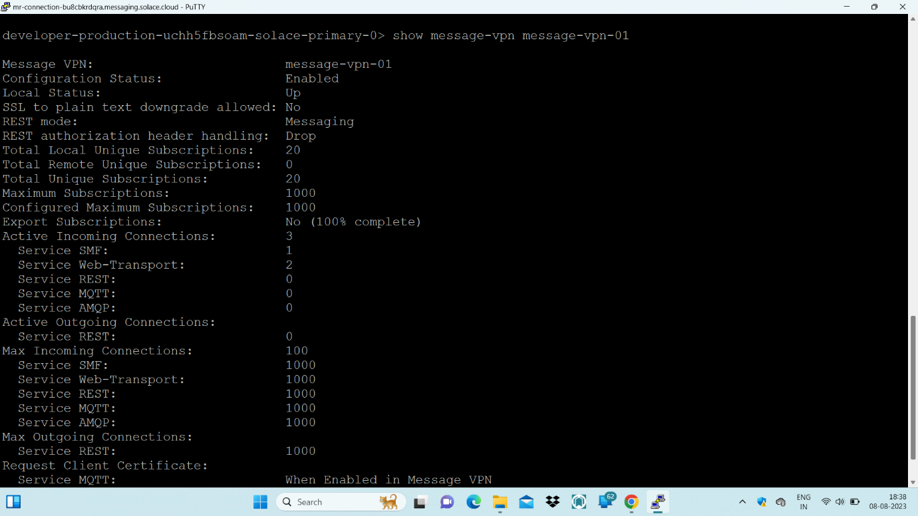

Detail about session-🡪Command : show session

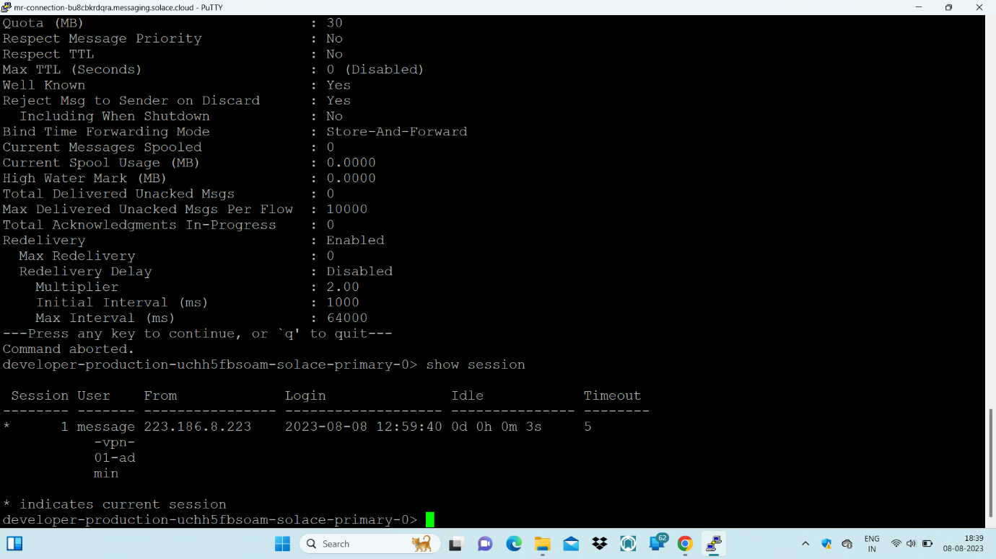

Default Unit of the Timeout is Seconds…

Two queues created using SOLACE CLI and one queue is created using GUI

